CMSC 451 Homework 6

1. Using Warshall’s algorithm, compute the reflexive-transitive closure of the relation below. Show the matrix after the reflexive closure and then after each pass of the outermost for loop that computes the transitive closure.

|  |  |  |  |  |
| --- | --- | --- | --- | --- |
| 0 | 0 | 0 | 0 | 1 |
| 1 | 0 | 0 | 0 | 0 |
| 0 | 0 | 1 | 1 | 0 |
| 0 | 0 | 1 | 0 | 0 |
| 1 | 0 | 1 | 0 | 1 |

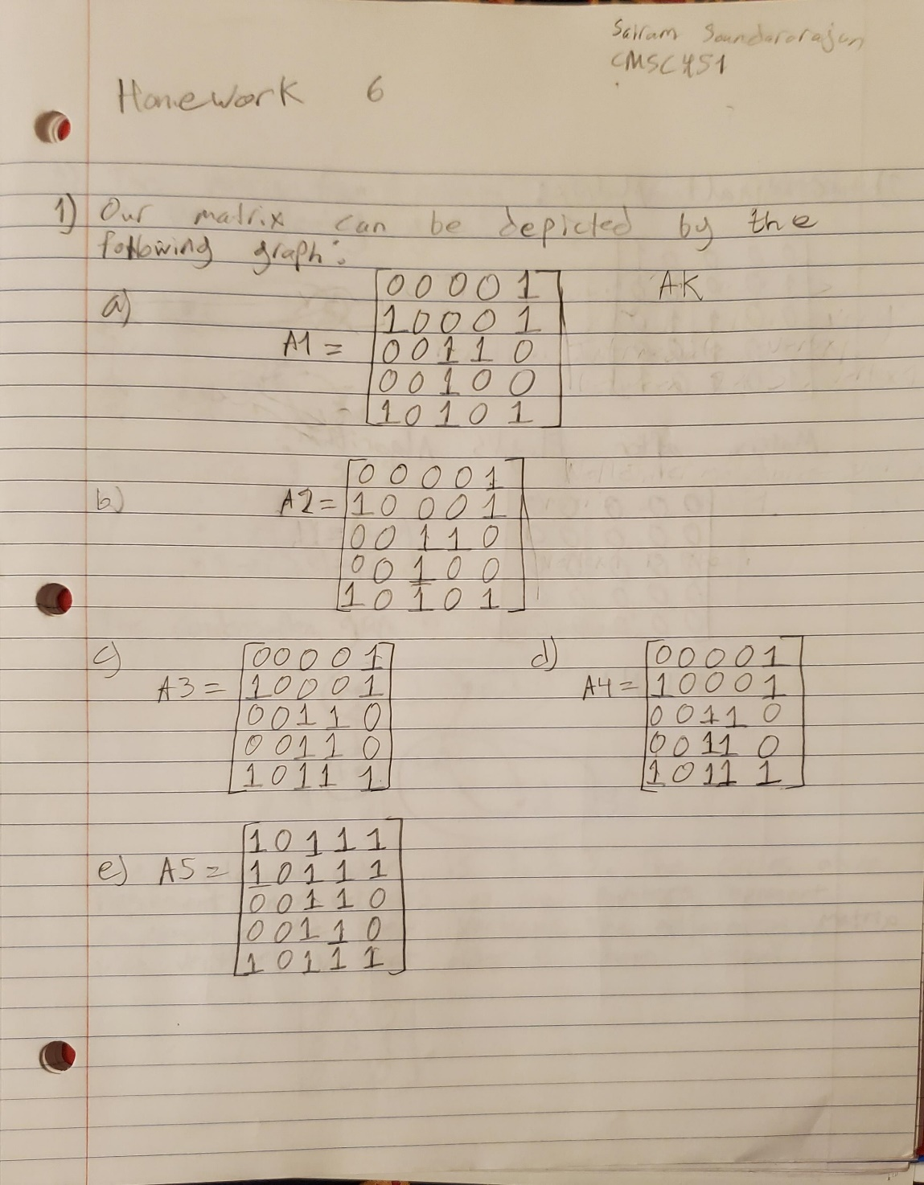

1. Using the matrix in the previous problem show the final result of executing Floyd’s algorithm on that matrix to produce a matrix containing path lengths.

1. Show the graph that corresponds to the matrix in the first problem assuming the rows and columns correspond to the vertices a, b, c, d and e. Show its condensation graph, renaming its vertices. Determine any topological order of that graph and create an adjacency matrix with the vertices ordered in that topological order. Finally compute the reflexive-transitive closure of that matrix. What characteristic of that matrix indicates that it defines a total order?

Continued on the next page

Problem 3 continued

1. Using Floyd’s algorithm, compute the distance matrix for the weight directed graph defined by the following matrix:

0 4 ** 5

[ 2 0 3 3]

** 2 0 **

−2 ** −4 0

Show the intermediate matrices after each iteration of the outermost loop.

Grading Rubric

|  |  |  |
| --- | --- | --- |
| **Problem** | **Meets** | **Does Not Meet** |
| **Problem 1** | **10 points** | **0 points** |
|  | |
| Showed the correct matrix after the reflexive closure (2) | Did not show the correct matrix after the reflexive closure (0) |
| Showed the correct matrices after each pass of the outermost for loop that computes the transitive closure (8) | Did not show the correct matrices after each pass of the outermost for loop that computes the transitive closure (0) |

|  |  |  |
| --- | --- | --- |
| **Problem 2** | **10 points** | **0 points** |
|  | |
| Showed the correct final result of  executing Floyd’s algorithm on that matrix to produce a matrix containing path lengths (10) | Did not show the correct final result of executing Floyd’s algorithm on that matrix to produce a matrix containing path lengths (0) |
| **Problem 3** | **10 points** | **0 points** |
|  | |
| Showed the correct graph that corresponds to the matrix in the first problem assuming vertices a, b, c, d and e (1) | Did not show the correct graph that corresponds to the matrix in the first problem assuming vertices a, b, c, d and e (0) |
| Showed its correct condensation graph, renaming its vertices (2) | Did not show its correct condensation graph, renaming its vertices (0) |
| Determined a correct topological order of that graph (2) | Did not determine a correct topological order of that graph (0) |
| Created a correct adjacency matrix with the vertices ordered in that topological order (1) | Did not create a correct adjacency matrix with the vertices ordered in that topological order (0) |
| Correctly computed the reflexive- transitive closure of that matrix (2) | Did not correctly compute the reflexive-transitive closure of that  matrix (0) |
| Correctly explained what characteristic of that matrix indicates that it defines a total order (2) | Did not correctly explain what characteristic of that matrix indicates that it defines a total order (0) |
| **Problem 4** | **10 points** | **0 points** |
|  | |
| Showed the correct intermediate matrices after each iteration of the  outermost loop using Floyd’s algorithm (7) | Did not show the correct intermediate matrices after each iteration of the  outermost loop using Floyd’s algorithm (0) |
| Showed the correct final matrix after executing Floyd’s algorithm (3) | Did not show the correct final matrix after executing Floyd’s algorithm (0) |